DATEBOOK
Friends of the Library
FOURTH TUESDAY
6:15 p.m.

Library Board of Trustees
THIRD TUESDAY
7:00 p.m.

Adult Book Club
SECOND (OR THIRD) WEDNESDAY
Noon -2:00 p.m.

Teen Book Club
MONTHLY according to member availability. Call the library for next scheduled meeting date.

Knit and Stitch
FIRST AND THIRD MONDAY
6:30- 8:00 p.m.

Library Hours
MON: 2:00 p.m. - 8:30 p.m.
TUE WED FRI: 2:00 -5:00 p.m.
THU: 2:00 p.m. – 8:00 p.m.
SAT: 10:00 a.m. -12:00 p.m.

  - gEORGE p. AND SUSAN pLATT cADY LIBRARY – nichols, new york

cady-did news

time to upgrade

by Patrick Roberts
The computer industry is ever growing and changing, with new technology and software being implemented almost on a daily basis. Sometimes this technology becomes outdated and needs to be replaced. A couple of years ago, Microsoft discontinued support and updates for Windows XP. With the lack of support for this operating system, systems running Windows XP become more vulnerable to computer viruses and other security issues.
Currently, the Nichols Cady Library is running Windows XP on its public computers. This poses an issue to patrons as the lack of security means any private information could more easily be taken from them. However, the library will soon be getting an upgrade to its public computers. Ginny Okrasinski of the library board, while acting as temporary director obtained a grant for new computers. These new computers will be running the latest Microsoft operating system, Windows 10. Just released last year, Windows 10 gets frequent updates to help protect the security of library patrons.
The new public computers are expected to be up and running by the end of September. The library itself needs to match the $8000 grant monies with an additional $1500 to complete the purchase of the computers. Tax deductible donations towards this purpose can be directed toward The Friends of the Library, P.O. Box 70, Nichols, NY 13812.

Summer vacation has begun!
by Xun Jiang
Many of us are looking forward to enjoying our summer vacation, relaxing and having fun. However, it is critical that we encourage our children to keep reading throughout their summer vacation. Research shows that summer reading can help prevent “summer slide” and build a strong literacy foundation for the next school year. Thus, we invite parents and children in our community to join us for our July 2016 Summer Reading Program. We have a wide range of events for children including story time, sports demonstrations, obstacle course, mini games, and pirate treasure hunt. These programs will take place on July 8, 15, 22, and 29 at 12:30 PM and are free to the public. We encourage parents to sign up and join us in a series of exciting events. Please contact us if you have any questions or concerns.

The Teen Book Club is planning a Game Night for teens at the library to take place sometime in August. In July, the teens will be helping with the children’s Summer Reading Program.

friends of the library

The Friends of Library meets the Fourth Tuesday of every month at 6:15 p.m. Upcoming events include the annual book sale which takes place during the Nichols Old Home Day Festivities on Labor Day 2016. Join us on the library lawn for great books at unbeatable prices.

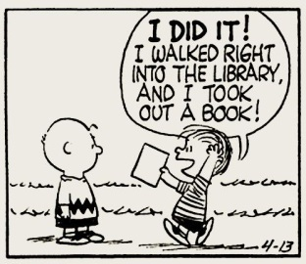

Recent books discussed include Dearest Friend, a story of Abigail Adams. David McCullough's Pulitzer Prize-winning biography, John Adams was recommended for further reading. Both books are available in the Finger Lakes Library System, as well as DVDs of the 2008 HBO miniseries adaptation of John Adams.
The Silkworm by Robert Galbraith (aka J.K. Rowlings, the Harry Potter series author) is a murder mystery with descriptions that are sometimes “brutal and bleak,” according to one club member. There are many characters to follow, including some that are likely to appear in future books by this author.
A host of memorable characters and lively dialogue made Miss Julia Meets Her Match, by Ann B. Ross a fun, quick summer read. The story also addresses some contemporary social issues in an intelligent and sensitive manner with words of wisdom about marriage and family throughout,
Join the Book Club on August 10 to discuss An Irish Country Doctor, the first in the Irish Country series by Irish-Canadian author Patrick Taylor. On September 14, we’ll focus on Patrick Heller’s 2014 suspense novel The Painter, a modern western about an artist trying to outrun his past.

knit And Stitch

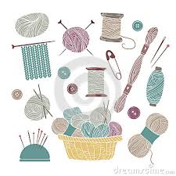

Knit and Stitch meets on the First and Third Monday of each month from 6:30 to 8:00 p.m. at the Library. All types of yarn and thread crafters are welcome.

computer update

Patrons using the library’s computers for internet access should be especially cautious with personal information until upgrades are in effect. (See front page.)

Contact the Library

Phone: 607- 699-3835
Fax: 607- 699-3835
Website: cadylibrary.org
Mailing Address:
P.O. Box 70
Nichols, NY 13812

